一：
手机号：18662341026
邮箱：info@cinnystore.com
whatsapp:+8615716200631
二：
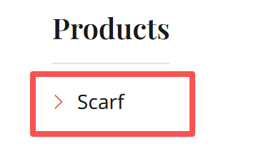
改成Beach Towel
三：
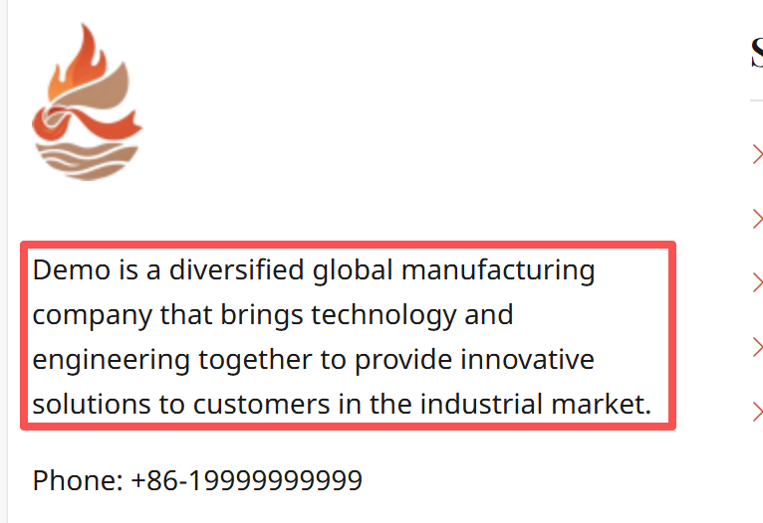
改成：Welcome to Cinny's Store, our little corner of the internet where we share our passion for quality textiles with you. Cinny's Store is more than just a shop. Welcome to Cinny's Store, our little corner of the internet where we share our passion for quality textiles with you. Cinny's Store is more than just a shop.
四：
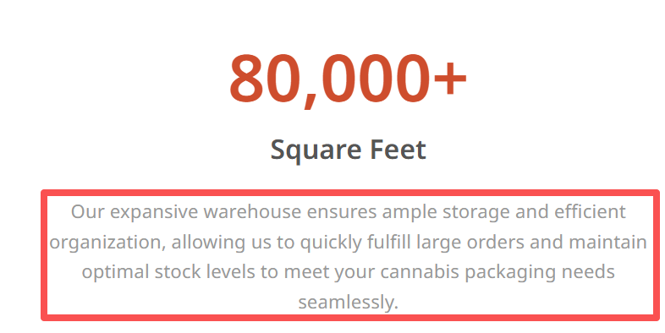
改成：Our expansive warehouse ensures ample storage and efficient organization, allowing us to quickly fulfill large orders and maintain optimal stock levels to meet your beach towel needs seamlessly.
五：
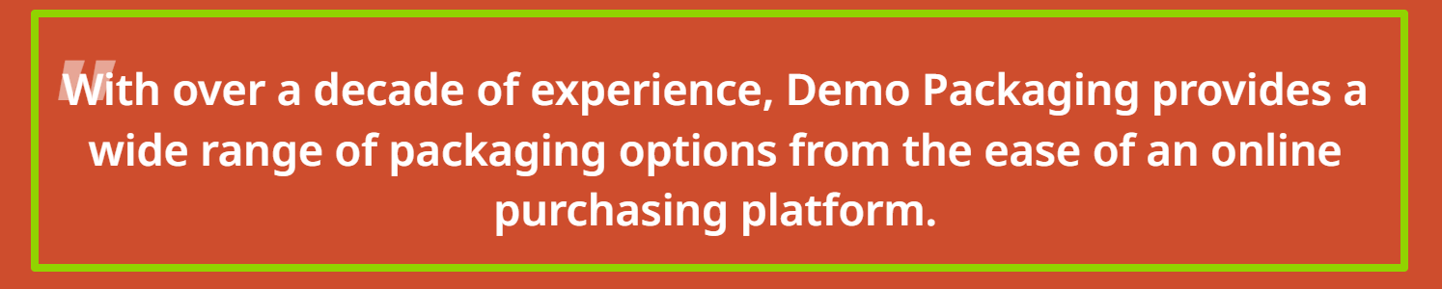
改成：Hot Products
We have rich experience in ultrafine fiber and a professional team
格式参考下图：
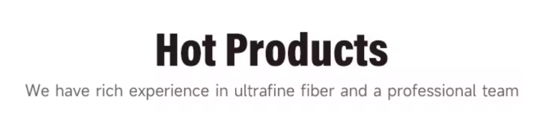
六：这部分图片在文件夹2
①
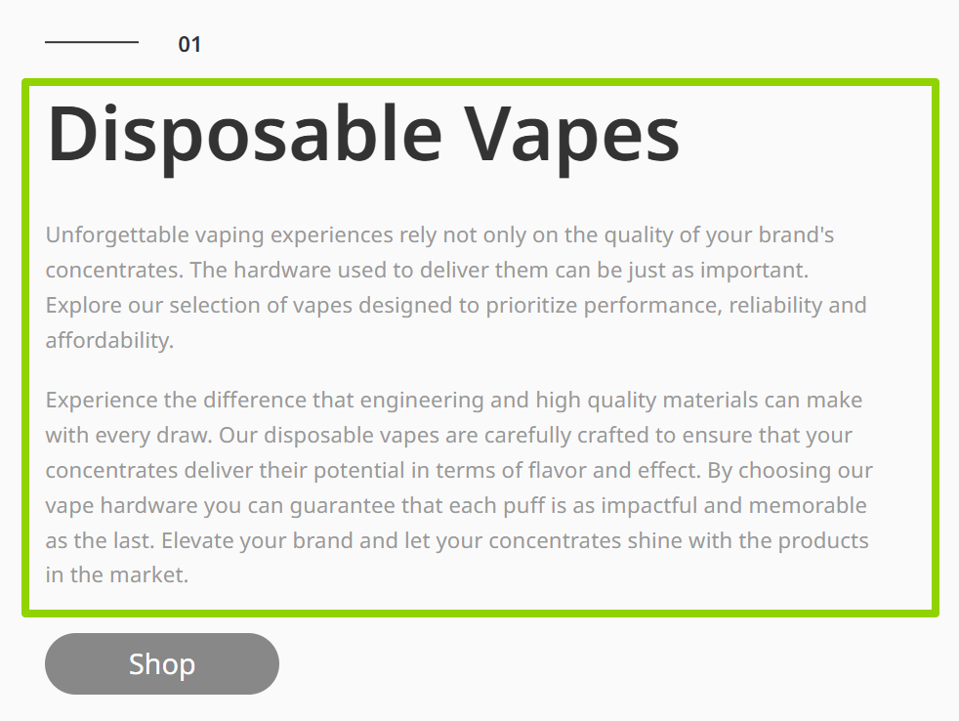
小标题改：BEACH TOWEL
正文改：Microfiber Quick Dry Beach Travel Towel, dear care you, give you the softest love.
②
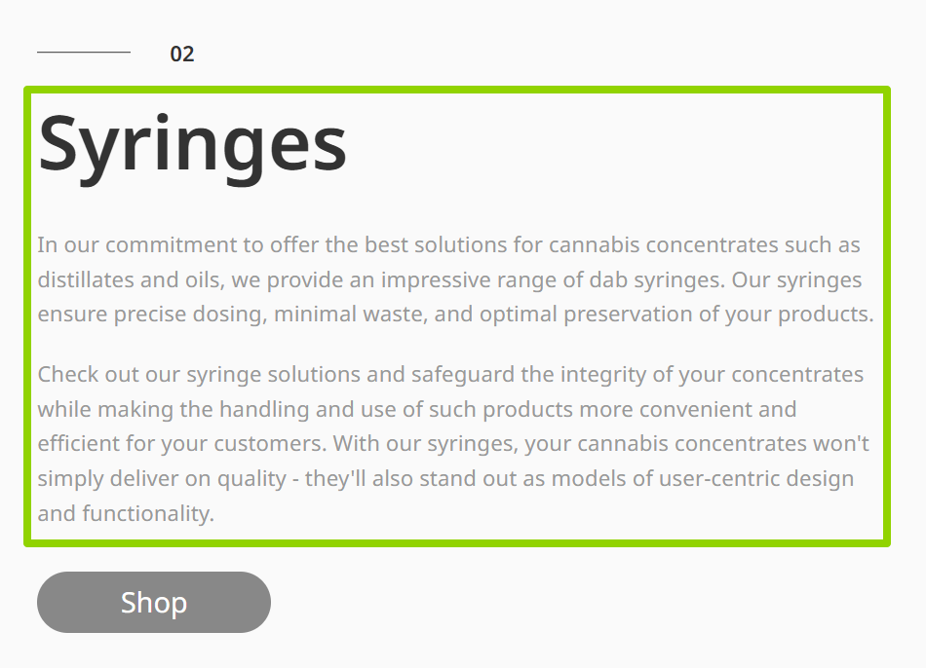
小标题改：PONCHO
正文改：Super absorbent beach swim pool camping outdoors sports travel towel , dear care you, give you the softest love.
③
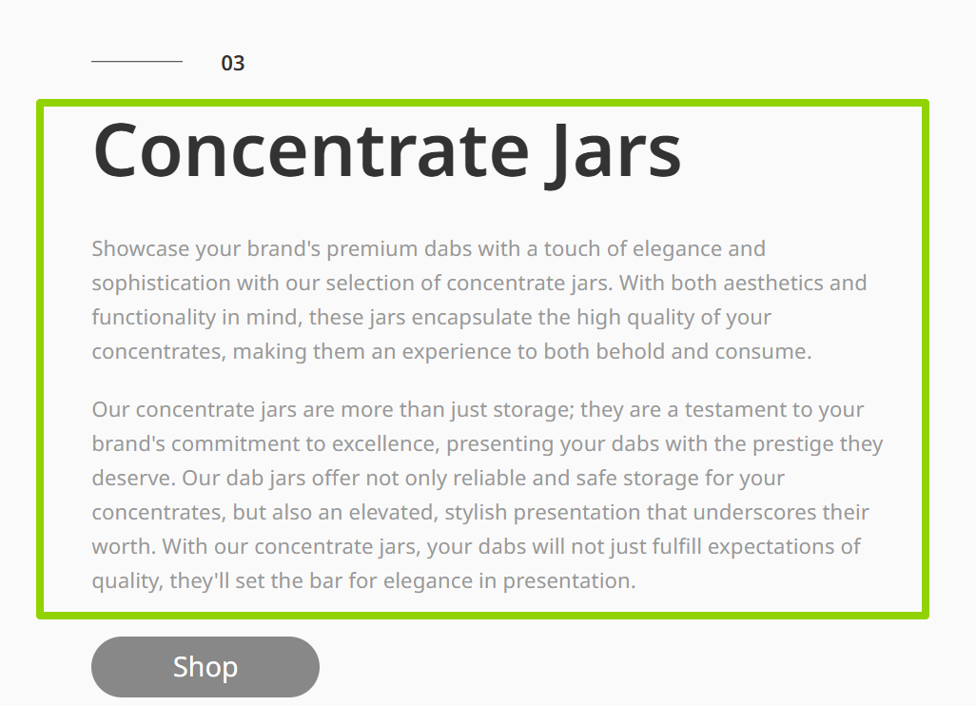
小标题改：WEARABLE BEACH TOWEL
正文改：Lightweight Microfiber Rectangle Beach Towel Sand-Free with Floral Pattern Wearable and Antimicrobial for Travel.
④
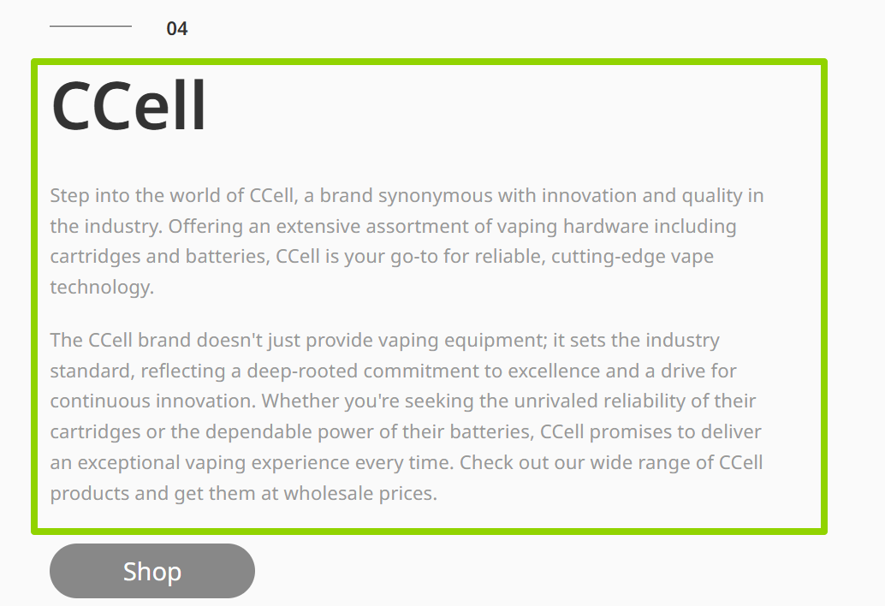小标题改：GYM TOWEL
正文改：Lightweight & Compact Towel for sports pool,beach, dear care you, give you the softest love.
七：
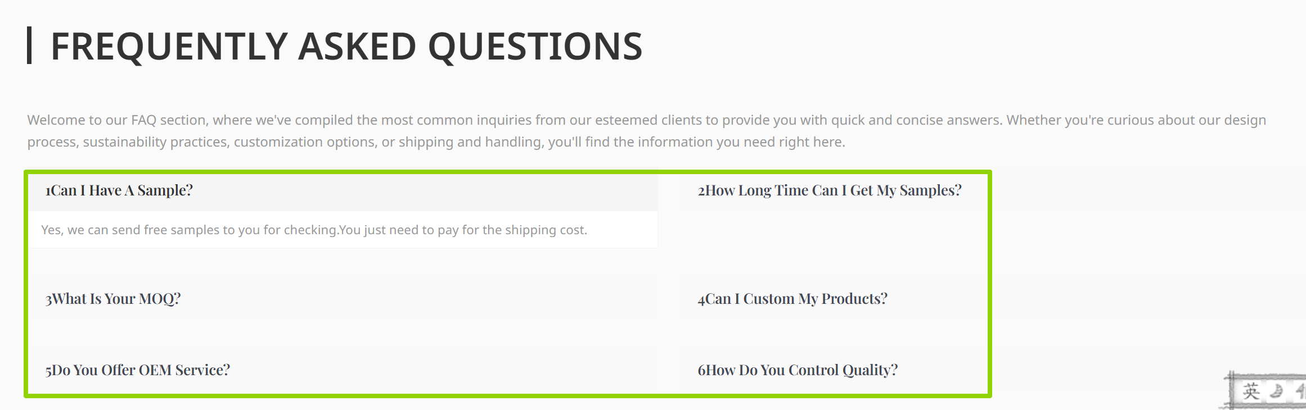
1. Can I Have A Sample?
Yes, we can send you the sample for checking our quality, you need pay sample fee, we will refund to you once you place the order from us. And the order amount is more than USDl500. This is to show the sincerity of business cooperation, hope you can support.
2. Can we brand our logo on the products/tags/packages?
Yes, they are ok. And, different types of logo are supported.
For example, printing, embossed, embroidery, etc.
3. Do you provide OEM service?
Yes, we accept OEM service. The products could be customized by your requirements. Such as color, size, logo, packing, printing, pattern and so on. For printing design, PDF or Al format files are ok.
4. If quantity of the order is very small ,like 50pcs per style per color ,could we accept it?
Yes, we can do it.
5.What's the delivery time for bulk order?
For customized colors and printing, it is usuallyabout 15-20days ;
For some present colors, it takes about 7-10days.
6. What about the shipping way?
Depend on customers’request. By sea, by air, by express(UPS/FedEx/TNT/DHL).

